**Question 1**

**Diagram**

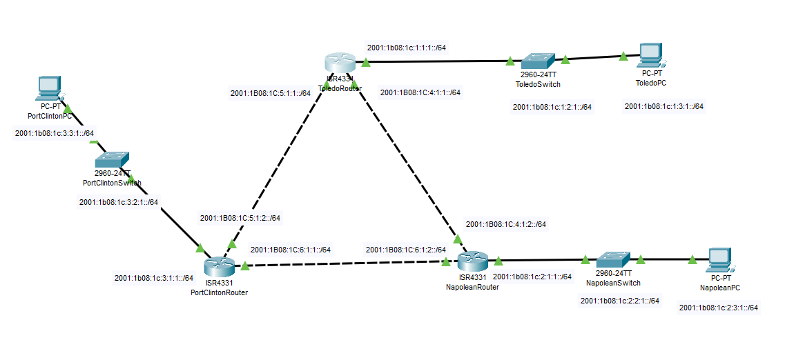

|  |  |  |  |
| --- | --- | --- | --- |
|  | **Toledo** | **Napolean** | **Port Clinton** |
| Fa0 | 2001:1B08:1C:1:1:1::/64 | 2001:1B08:1C:2:1:1::/64 | 2001:1B08:1C:3:1:1::/64 |
| Fa1 | 2001:1B08:1C:4:1:1::/64 | 2001:1B08:1C:4:1:2::/64 | 2001:1B08:1C:5:1:2::/64 |
| Fa2 | 2001:1B08:1C:5:1:1::/64 | 2001:1B08:1C:6:1:2::/64 | 2001:1B08:1C:6:1:1::/64 |

2001:1b08:001c::/48

1 – router

2 – switch

3 – PC

**Toledo**

2001:1b08:1c:1::/64

Router: 2001:1b08:1c:1:1:1::/64

Switch: 2001:1b08:1c:1:2:1::/64

PC: 2001:1b08:1c:1:3:1::/64

**Napolean**

2001:1b08:1c:2::/64

Router: 2001:1b08:1c:2:1:1::/64

Switch: 2001:1b08:1c:2:2:1::/64

PC: 2001:1b08:1c:2:3:1::/64

**Port Clinton**

2001:1b08:1c:3::/64

Router: 2001:1b08:1c:3:1:1::/64

Switch: 2001:1b08:1c:3:2:1::/64

PC: 2001:1b08:1c:3:3:1::/64

**Toledo-Napolean**

2001:1b08:1c:4::/64

**Toledo-Port Clinton**

2001:1b08:1c:5::/64

**Napolean-Port Clinton**

2001:1b08:1c:6::/64

**Question 2**

**Toledo**

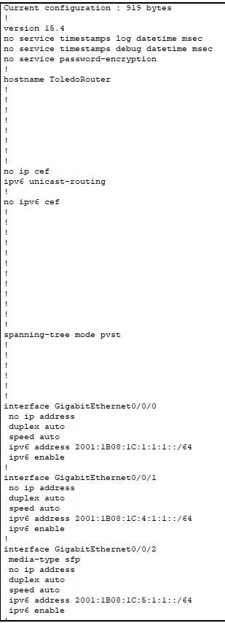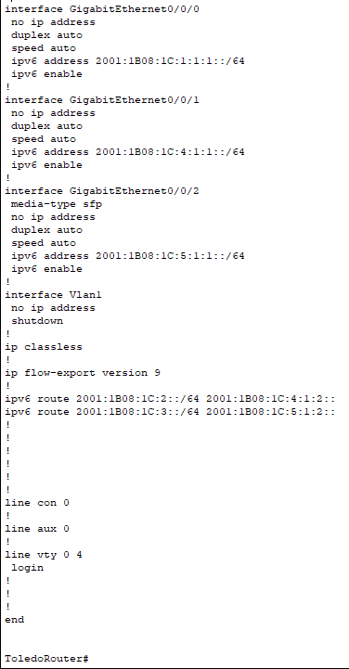

This is the Toledo router configured with IPv6 address and route.

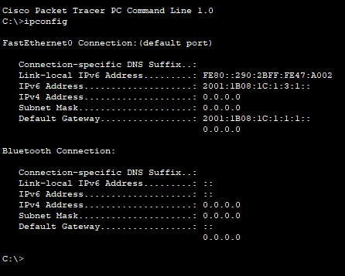

This is the Toledo PC configured with IPv6 address.

**Napolean**

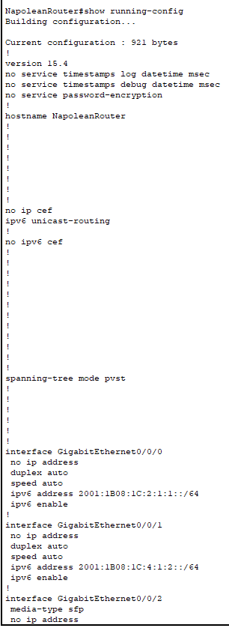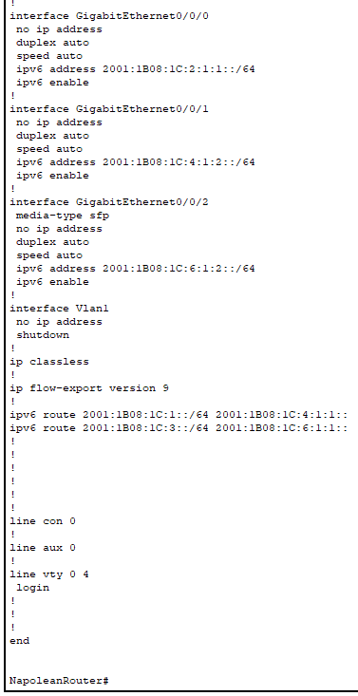

This is Napolean router configured with IPv6 address.

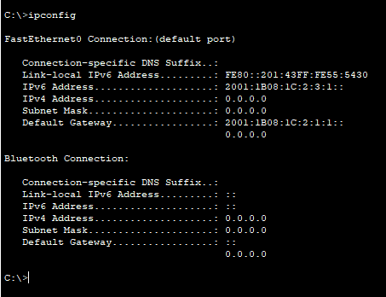

This is Napolean PC configured with IPv6 address.

**Port Clinton**

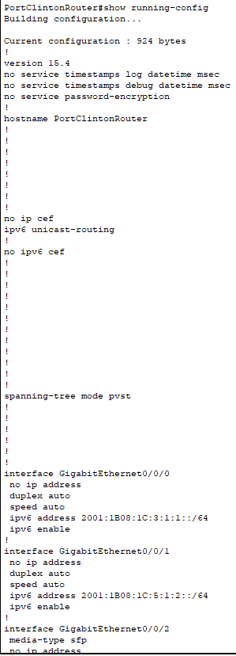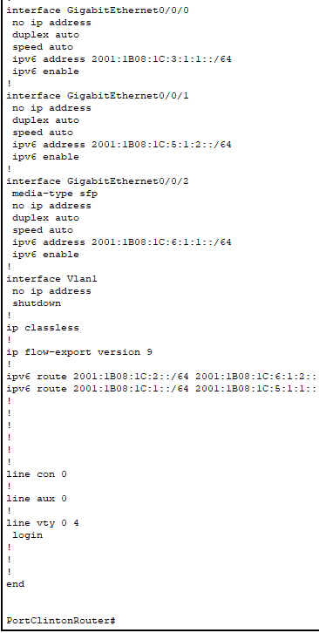

This is Port Clinton router configured with IPv6 address.

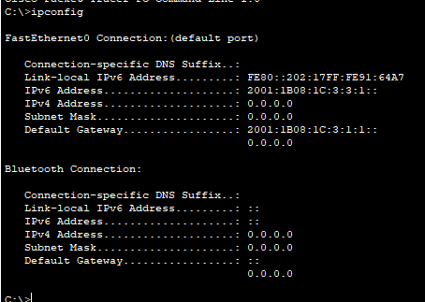

This is Port Clinton PC configured with IPv6 address.

**Question 3 - Static route**

**Toledo**

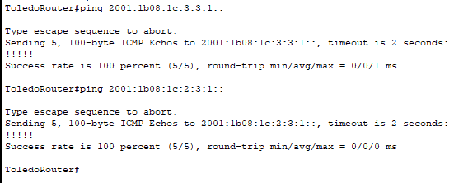

This is the screenshot of ping from Toledo router to Port Clinton PC and Napolean PC

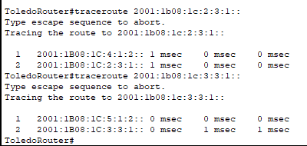

This is the screenshot of traceroute from Toledo router to Napolean PC and Port Clinton PC

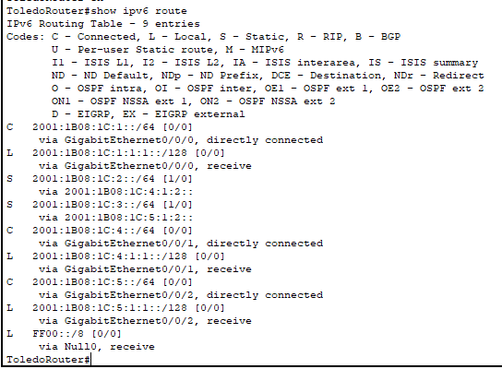

This is the screenshot of the route table from Toledo router

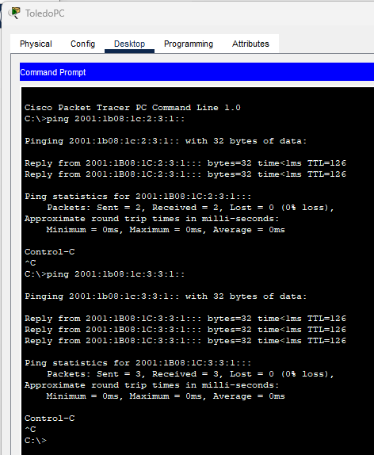

This is the screenshot of ping from Toledo PC to Napolean PC and Port Clinton PC

**Port Clinton**

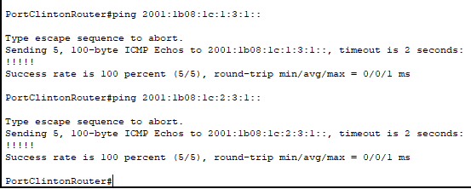

This is the screenshot ping from Port Clinton router to Toledo PC and Napolean PC

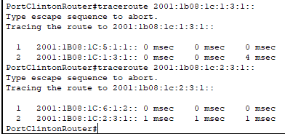

This is the screenshot of traceroute from Port Clinton router to Toledo PC and Napolean PC

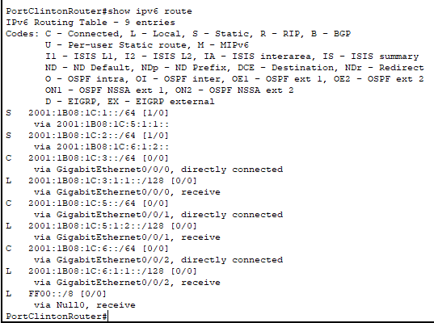

This is the screenshot of route table from the Port Clinton router

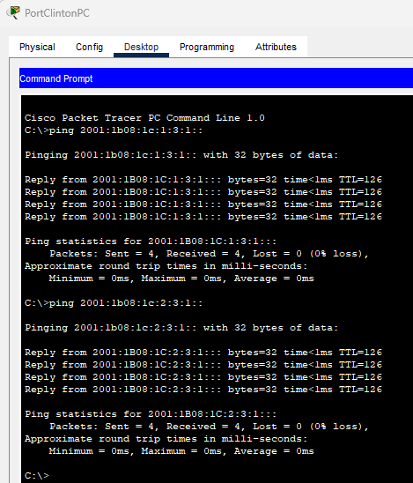

This is the screenshot of ping from Port Clinton PC to Toledo and Napolean PC

**Napolean**

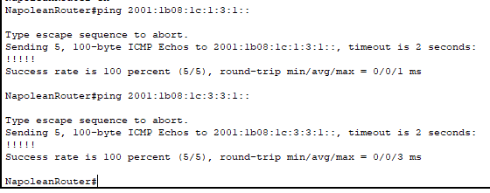

This is the screenshot of ping from Napolean router to Toledo PC and Port Clinton PC

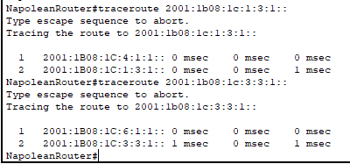

This is the screenshot of traceroute from Napolean router to Toledo PC and Port Clinton PC

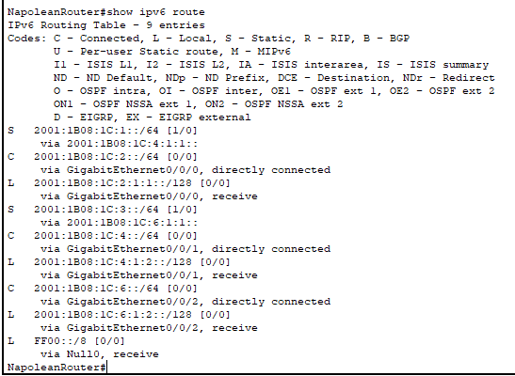

This is the screenshot of the route table from Napolean router

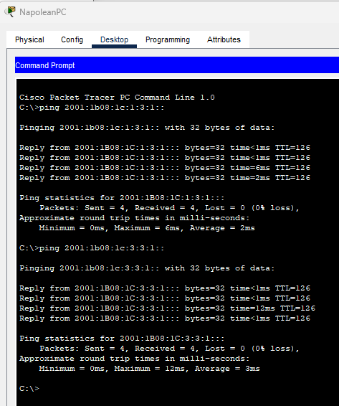

This is the screenshot of ping from Napolean PC to Toledo and Port Clinton PC

**Question 4 - RIP**

**Toledo**

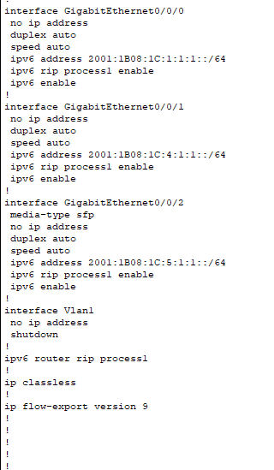

This is the run-config of Toledo router

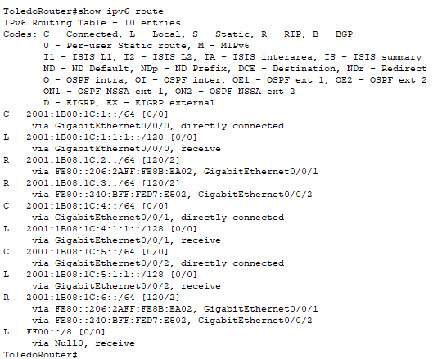

This is the route table

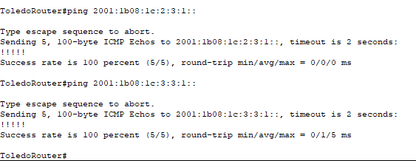

This is pinging from Toledo router to Napolean and Port Clinton PC

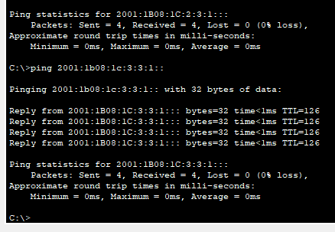

This is pinging from Toledo PC to Napolean and Port Clinton PC

**Napolean**

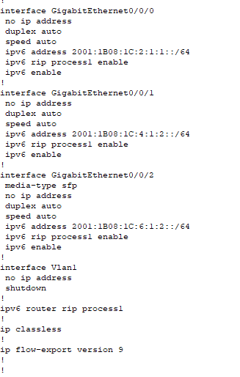

This is run-config of Napolean router

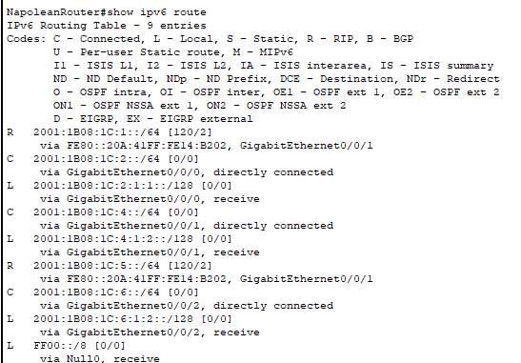

This is the route table of Napolean router

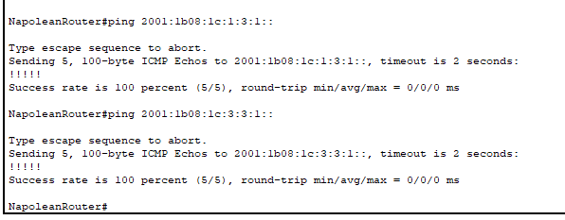

This is the ping from Napolean router to Toledo and Port Clinton PC

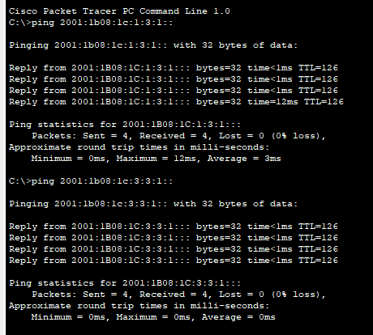

This is the ping from Napolean PC to Toledo and Port Clinton PC

**Port Clinton**

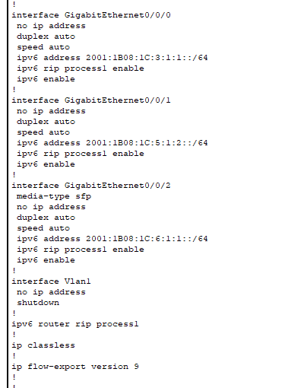

This is the run-config of Port Clinton router

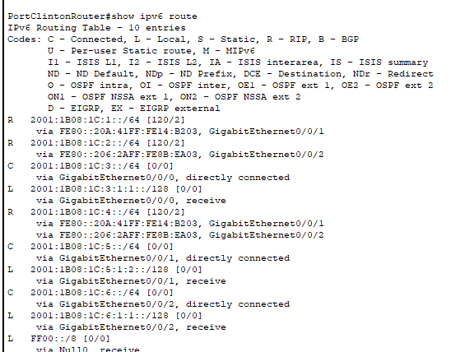

This is the route table

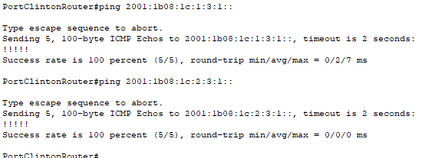

This is ping from Port Clinton router to Toledo and Napolean PC

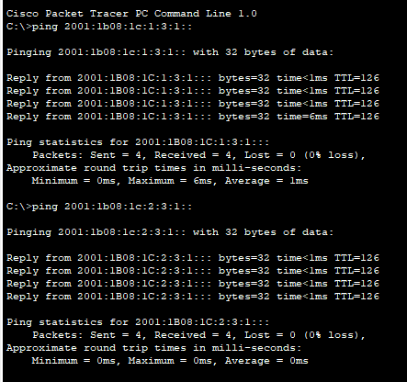

This is ping from Port Clinton PC to Toledo and Napolean PC

**Question 5 – OSPF**

**Toledo**

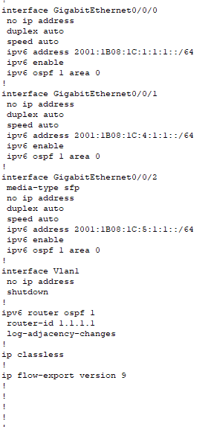

This is the run-config of Toledo router

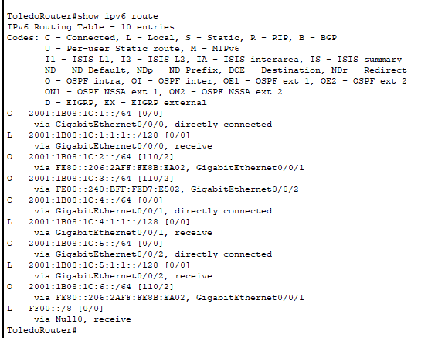

This is the ipv6 route table of Toledo router

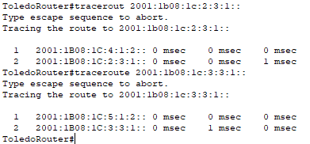

This is the traceroute command from Toledo router to Napolean and Port Clinton PC

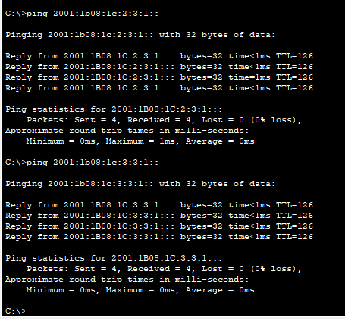

This ping from Toledo PC to Napolean and Port Clinton PC.

**Napolean**

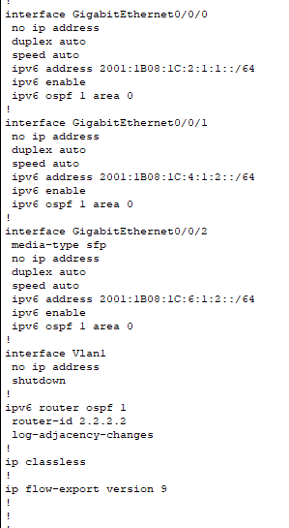

This is the run-config of Napolean router

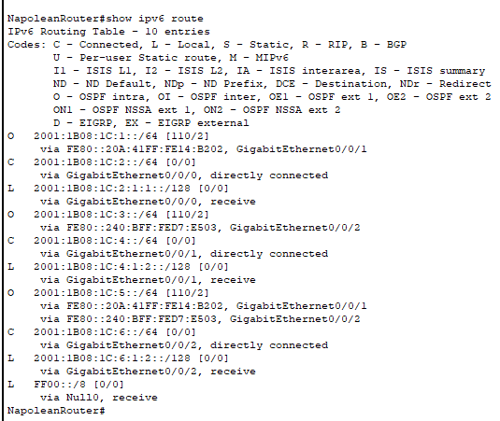

This is the route table

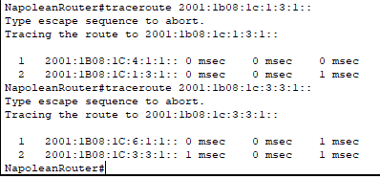

This is traceroute command to Toledo and Port Clinton PC

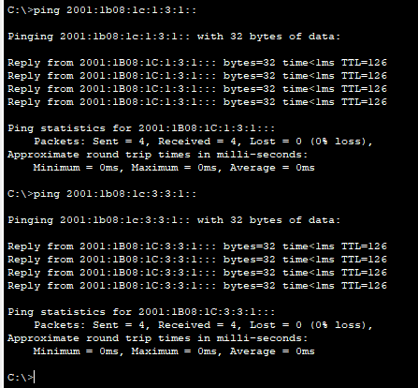

This is ping to Toledo and Port Clinton PC

**Port Clinton**

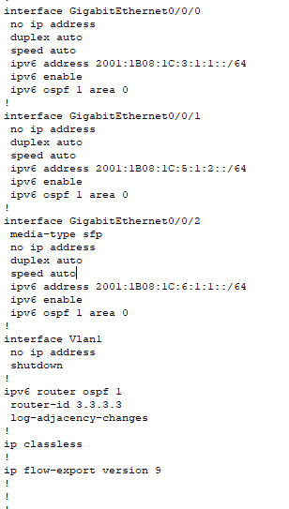

This is the run-config of Port Clinton router

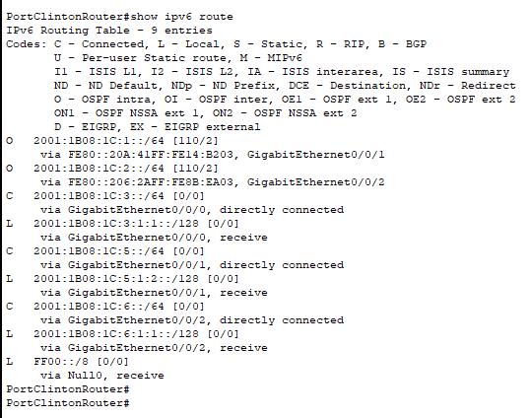

This is the route table

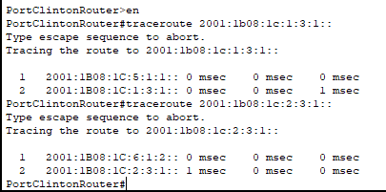

This is traceroute to Toledo and Napolean PC

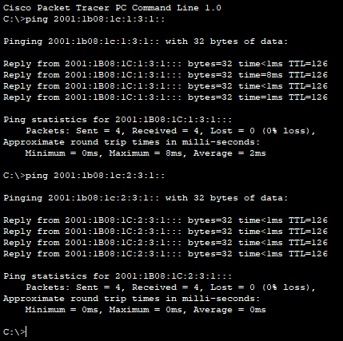

This is ping to Toledo and Napolean PC

**Question 6 – Ipv6 Extended ACL**

I only used created the extended ACL on Toledo site to block the ping from Napolean and Port Clinton.

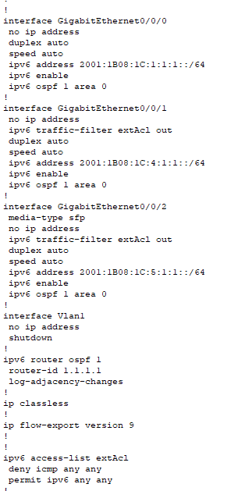

This is the run-config of Toledo router

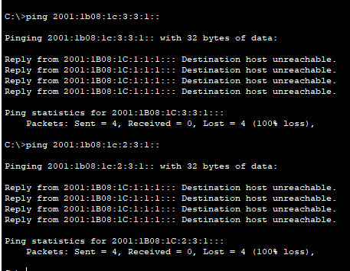

This is ping from Toledo PC to Napolean and Port Clinton PC

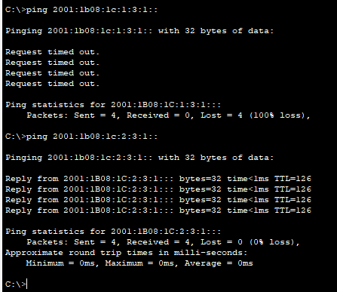

This is ping from Port Clinton PC to Toledo and Napolean PC. It is not able to ping Toledo PC but able to ping Napolean PC

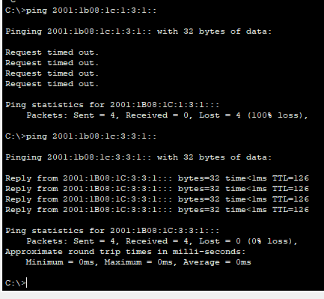

This is ping from Napolean PC to Toledo and Port Clinton PC. It is not able to ping Toledo PC but able to ping Port Clinton PC.